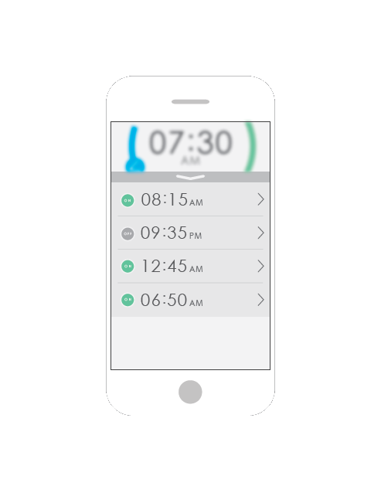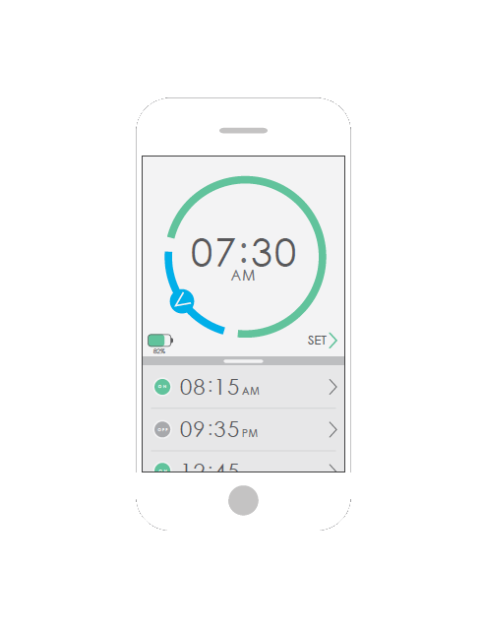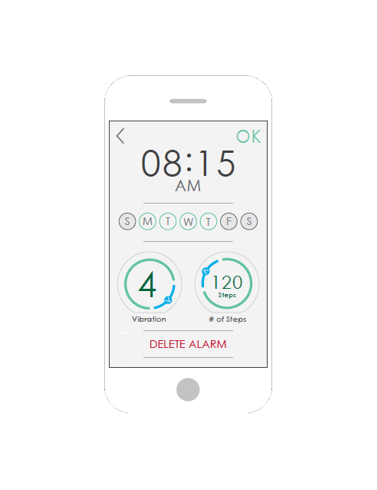

Alpha Alarm

The Alpha Alarm band is a simple, single purpose wristband that is meant to wake you up in the morning. Utilizing a state of the art algorithm, the wristband vibrates to wake you up and requires a certain amount of steps to be taken to turn off.

+

lorem ipsum